Human Behaviour Recognition Based on Multiscale Convolutional Neural Network

In propose work author applying 3DCNN algorithm for human behaviour prediction as all existing algorithms were directly employing global average information of each channel (taking all channels of images as single data) which ignores spatial and depth information from image features which leads to inaccurate recognition. If model has accurate information or each shape from the image then it can predict accurately. So in propose work author employed two different module such as space-time (ST) interaction module of matrix operation and the depth separable convolution module, combined with the research of human behaviour recognition. Combined with the superior performance of convolutional neural network (CNN) in image and video processing, a multi-scale convolutional neural network method for human behaviour recognition is proposed. Combination of spatial and depth separable module is known as Multiscale Convolution Neural Network (MCNN or MDN). Propose model is experimented on UCI HAR dataset which captured human activity using Smart Phone. Propose model giving best accuracy compare to existing CNN2D or LSTM.

In propose algorithm author has reduced training complexity by implementing MCNN model using CNN3D architecture which is lighter in training and can reduce complexity. Propose model MCNN CNN3D required 3300 training parameters and existing CNN2D required 9000 parameters.

We have compared both existing CNN2D and propose MCNN (CNN3D) in terms of training complexity and accuracy and in both model propose work accuracy is high and complexity is less.

Extension Concept

To further enhance accuracy we have combined 3 algorithms together called CNN + GRU + Bidirectional with less number of training parameters which help in further reducing model complexity with 1000 parameters and its accuracy is high compare to propose and existing algorithms. Extension hybrid optimizing training features with 3 different CNN + GRU + Bidirectional which helps in obtaining more optimized features which in turn give better accuracy.

Dataset Details

Propose work used UCI HAR dataset on human activity which contains 6 different labels such as Standing, laying, sitting, upstairs, downstairs and walking. All this activities is captured from smart phone. Above dataset can be downloaded from below link

<https://www.kaggle.com/datasets/drsaeedmohsen/ucihar-dataset/data>

In below screen displaying dataset values

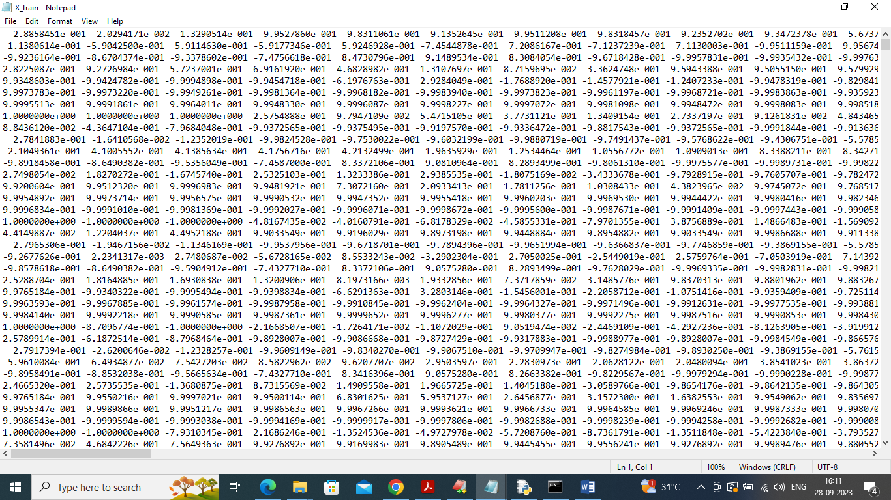

In above screen activities values captured by smart phone and by using above dataset we will train and test all algorithm performance.

SCREEN SHOTS

To Run the application Click on “run.bat” file from the file location.

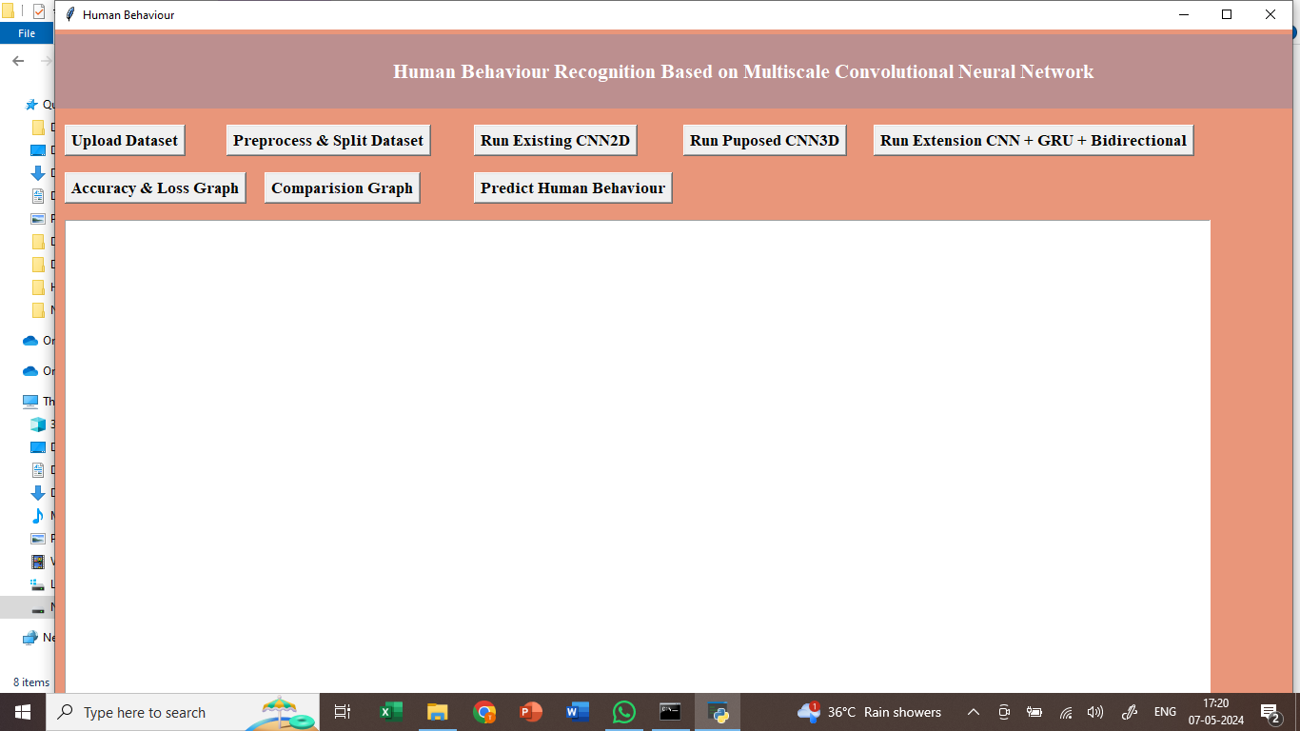

In the above screen we got Tkinter Output Window. Now Click On the “Upload Dataset” button to upload the dataset to the application.

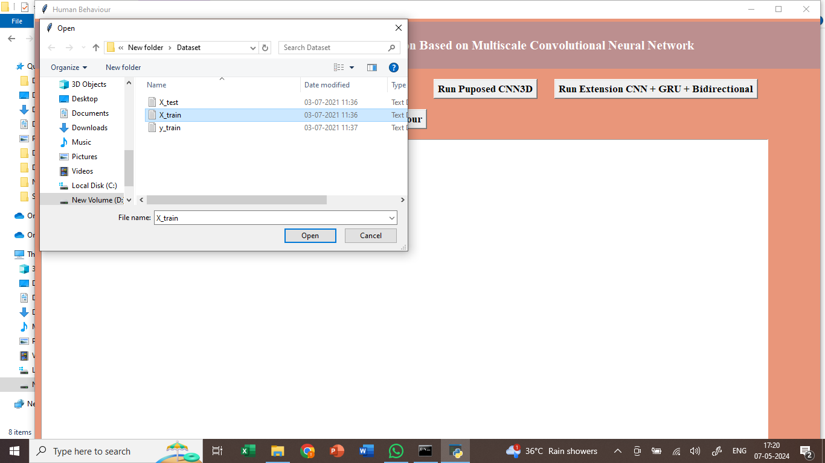

In the above screen we can see the dataset uploading.

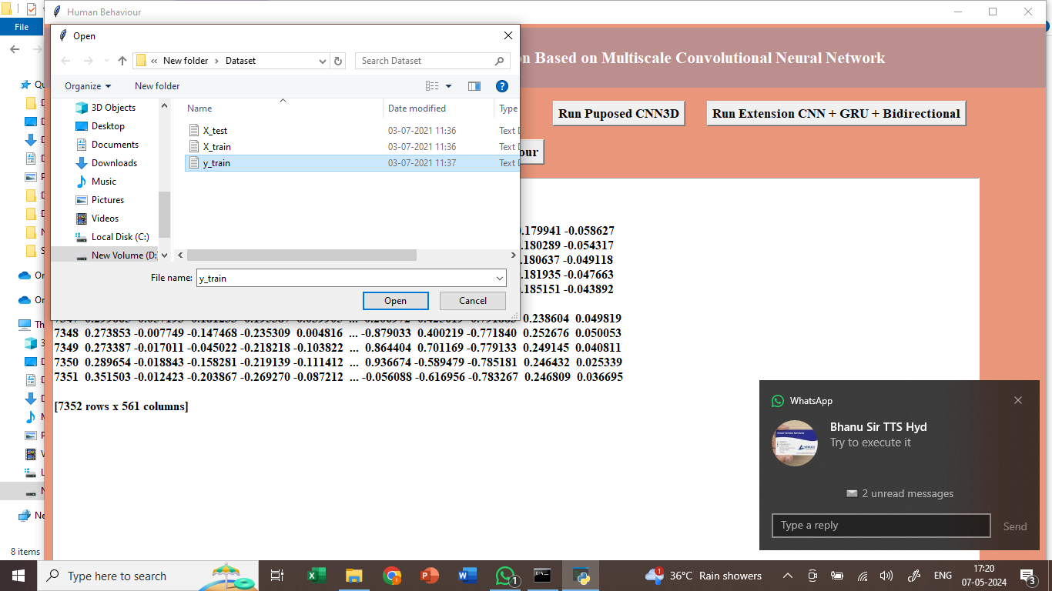

In above screen loading and displaying HAR dataset values captured from smart phone

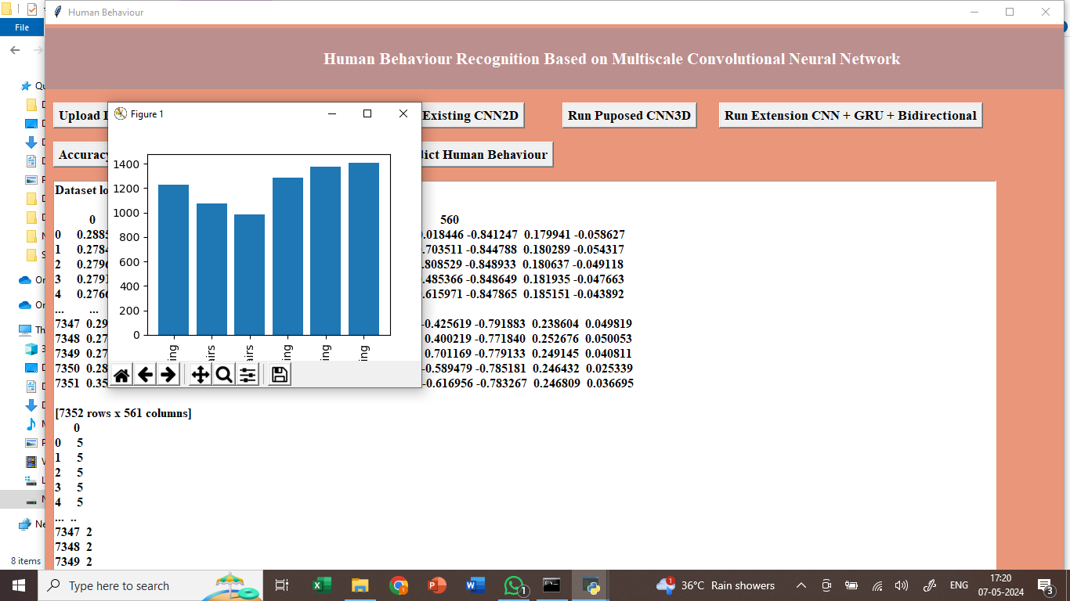

In above screen finding and plotting graph of different activities found in dataset where x-axis represents ACTIVITY NAMES and y-axis represents count of those activities

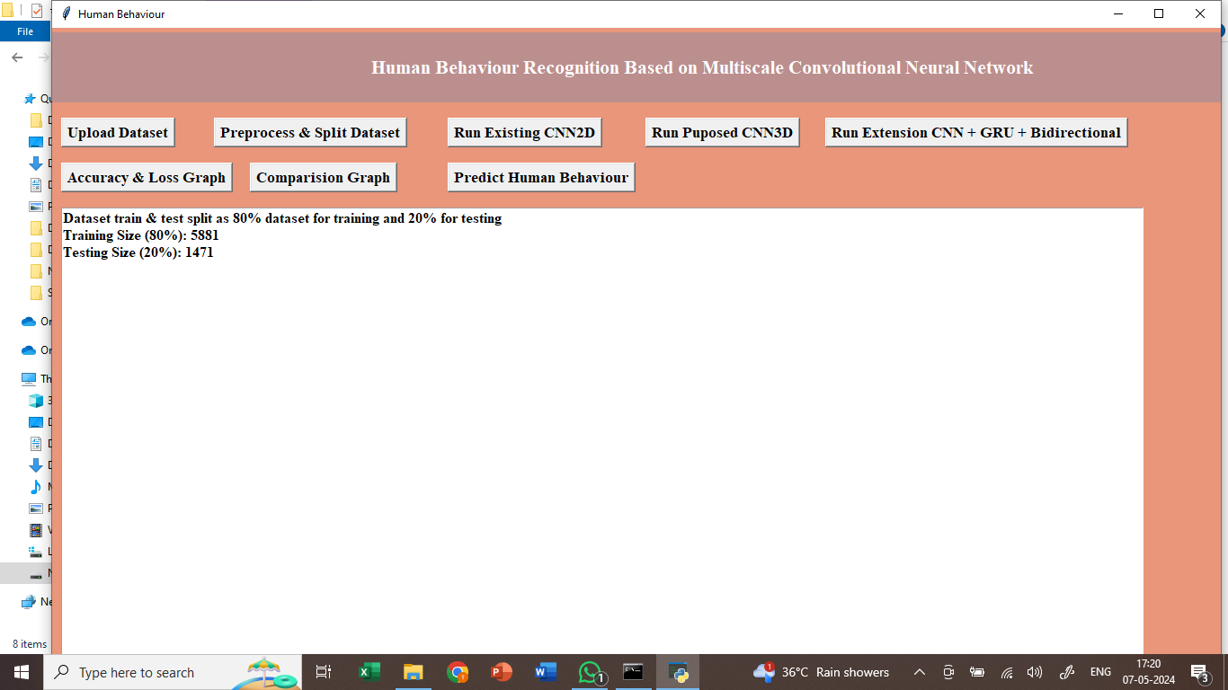

In above screen processing dataset and then splitting dataset into train and test and then can see total records used for training and testing.

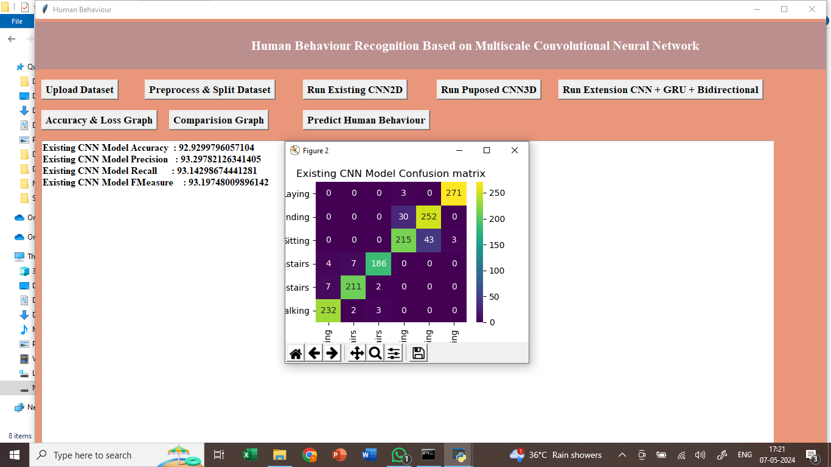

In above screen training existing CNN2D algorithm and can read blue colour comments to know about module and after executing above block will get below complexity of the model. In black console we can see existing CNN2D required 9135 parameters to train a model and increasing this parameters size can increase model complexity and training time and by decreasing we can reduce and in below screen we are performing prediction on test data. In above screen existing CNN2D model got 92% accuracy and can see other metrics and in confusion matrix x-axis represents predicted Labels and y-axis represents True Labels and all blue colour boxes represents incorrect prediction count and different colour boxes represents correct prediction count.

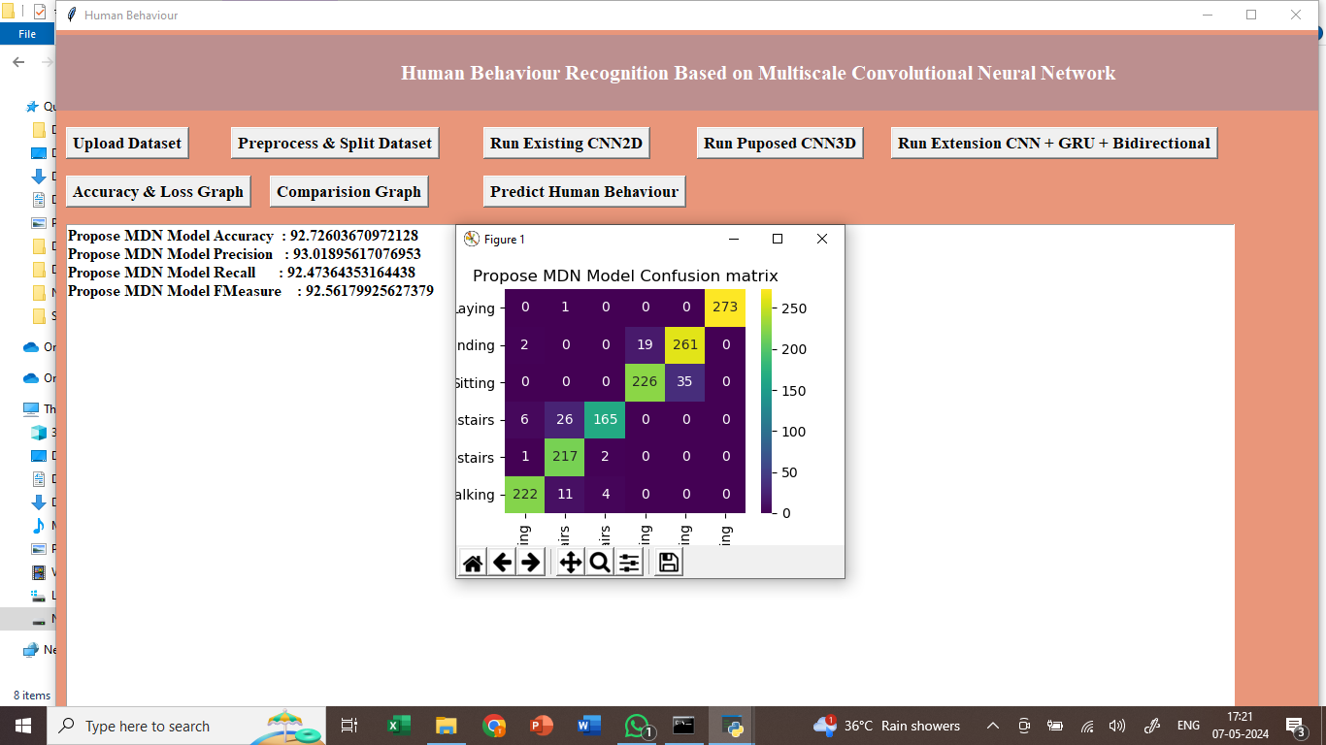

In above screen training propose MCNN (MDN) model using CNN3D architecture and after executing above model will get output . In the black console propose model required 3306 parameters for training which are lesser than existing CNN2D 9000 training parameters and below is the propose model accuracy. Propose MCNN MDN model got 94% accuracy and can see other metrics also.

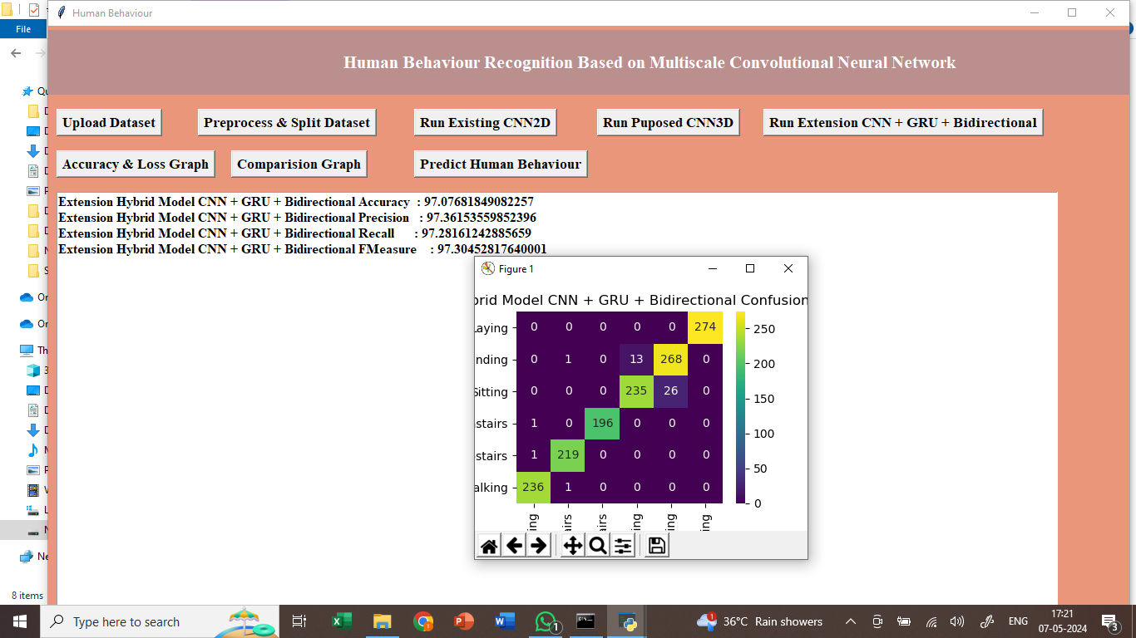

In above screen training extension model by combining 3 different algorithms such as CNN + GRU + Bidirectional and after executing above block will get output. In the black console extension model required 1162 parameters for training which are lesser than propose and existing models and below is the accuracy. Extension model got 96% accuracy and we can see the other metrics also.

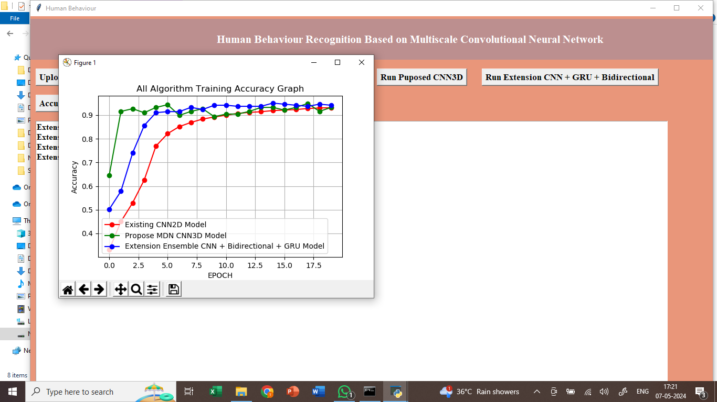

In above screen displaying training accuracy of all 3 models such as existing , propose and extension where x-axis represents training epoch and y-axis represents accuracy and with each increasing epoch accuracy got increase and in in all models extension got high accuracy.

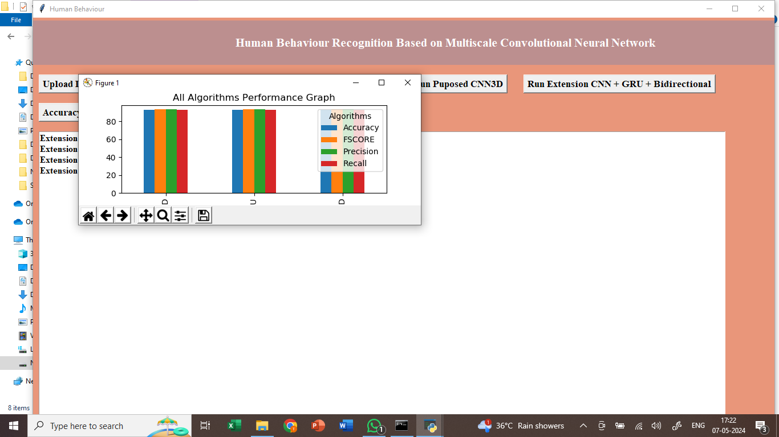

In above comparison graph x-axis represents algorithm names and y-axis represents accuracy and other metrics in different colour bars and in all algorithms extension got high performance.

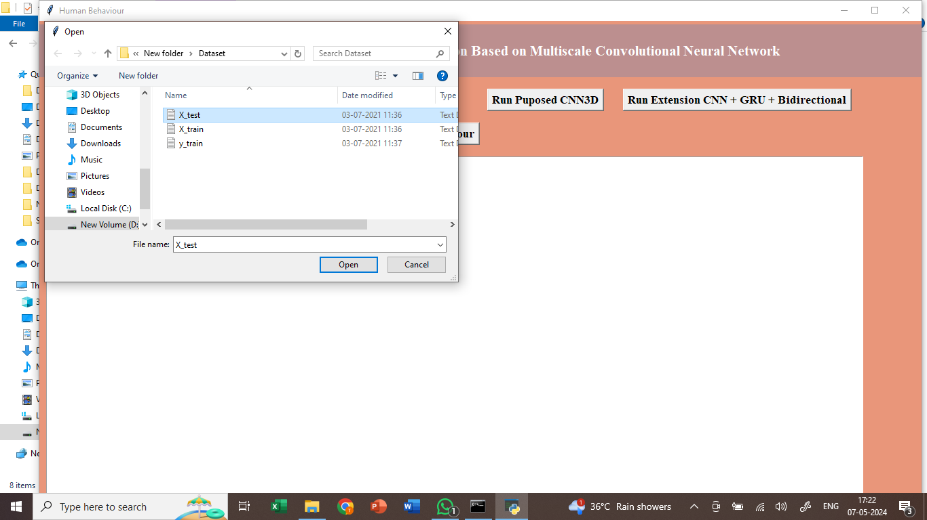

In above screen loading test data .

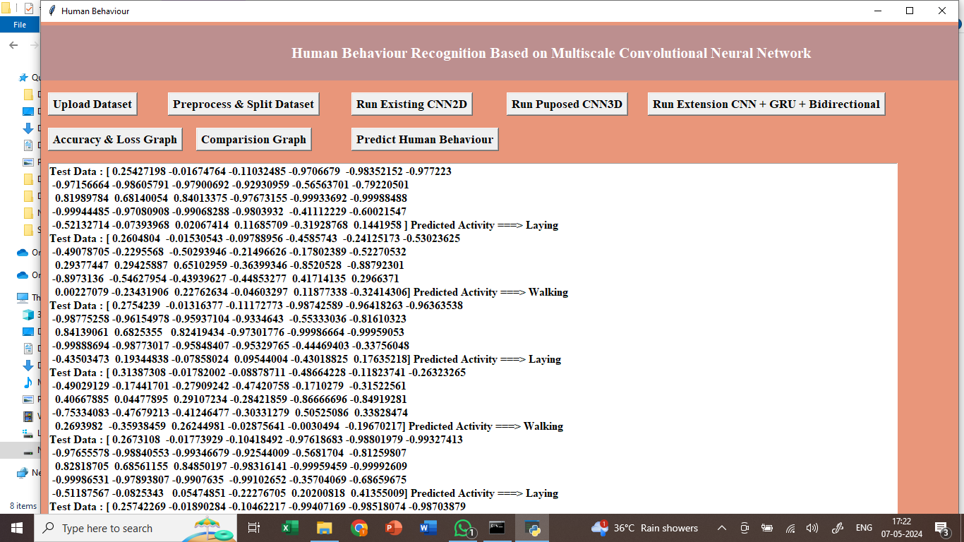

In above screen loaded test data and then predicting using extension model and in output in square bracket we can see Test Data Values and after arrow symbol can see predicted activity as Standing or any other activity.

Note: sometime propose model accuracy may be less so rerun all modules to avoid that error.